Wednesday, September 2, 2015

Myths about College Degrees and the Job Economy
John Cassidy’s New Yorker article “The College Calculus: What’s the real value of a collegeeducation” does a good job at revealing many of the popular myths currently circulating around the country concerning college degrees, jobs, and inequality. Drawing from Claudia Goldin and Lawrence Katz 2008 book The Race Between Education and Technology, he examines the logic behind the idea that we are failing to produce enough high-skilled workers with college degrees to keep up with technological progress. As Goldin and Katz have argued: “Not so long ago, the American economy grew rapidly and wages grew in tandem, with education playing a large, positive role in both. The challenge now is to revitalize education-based mobility.” The problem with this theory linking education to technology and social mobility is that it is false and misleading.
As Lawrence Mishel has stressed, since the mid-1970s, we have seen a constant separation between wages and productivity. The following graph shows that as workers using new technologies produce more goods and profits, their wages have remained relatively flat:
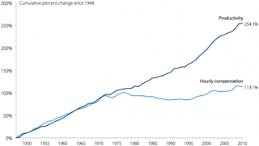

(click on image to enlarge)
Thus as education levels and technological advances have increased since 1970, the profits generated from these activities have not been shared with the average worker. The problem then is not a question of education or skills or even technology, the issue is how profits are distributed.

In an act of great ideological deception, business leaders and politicians have been able to turn our attention to higher education as the solution to wage stabnation because they do not want us to look at some of the real causes, like profit hording, de-unionization, financial speculation, executive pay, regressive taxation, and outsourcing. Cassidy points out that in place of dealing with these real economic issues, we are told that America has a fair meritocracy, and the key to economic advancement for individuals and the country as a whole is to produce more people with college degrees.

The myth of the meritocracy is an effective ideological tool because it tells us that if someone does not have a good job, it is their own fault. After all, we have a fair system of equal opportunity, which provides everyone the chance for social mobility. The reality of the situation is that our economic system is enhancing inequality and higher education is making things worse. Looking at the relation between family income and college attainment since 1970, we see that people in the top quartile income bracket who enter college have increased their degree attainment from 55% to 99%, while people from the bottom bracket have moved from 22% to 21% during the same forty-three-year period:
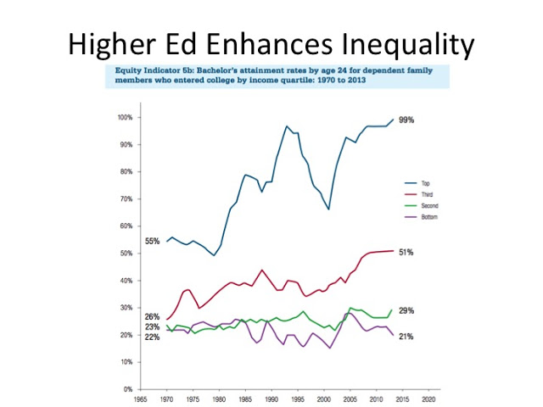
Therefore after trillions of dollars spent on financial aid and student loans, the people in the bottom 50% have seen virtually no gain in degree attainment, while the people at the top have experienced a massive growing advantage.

One reason why our meritocracy does not work in higher education is that many admissions decisions are based on SAT scores, and SAT scores are highly correlated with wealth. The following chart reveals this tight connection between parental income and SAT scores:
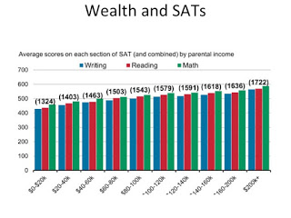

Since many college ranking systems like The US News & World Report rely heavily on SAT scores, universities and colleges who want to move up the ladder or maintain their high position have a huge incentive to only accept high scoring students, and this means for the most part, wealthy students. In fact, in order to both enhance their revenue and increase their status, these institutions, including selective public universities, have increasingly replaced need-based aid with merit aid, and once again merit is often defined by SAT scores:
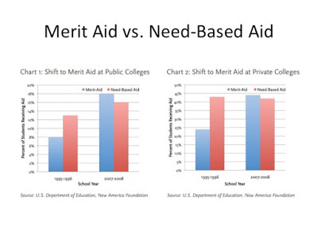
Public universities are therefore competing with each other for wealthy students by replacing low-income students who need financial aid with wealthy students who do not need aid but get it anyway.

As higher education continues to reward wealthy students with admissions to selective institutions, low-income students are mostly attending low-funded community colleges with low graduation rates. This system turns the meritocracy back into an aristocracy as the wealthy are able to use higher education as a way of further enhancing their positions of social power. Meanwhile, lower- and middle class families are putting themselves into debt in order to compete in a rigged game. In fact, the following chart shows that lower-income students are holding most of the student debt:
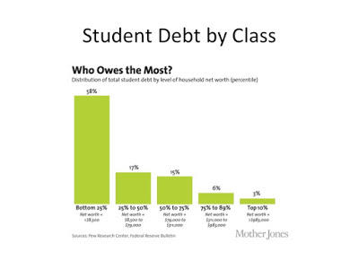
According to this chart, 58% of all student debt is owned by people whose household net worth is in the bottom 25%, and we should remember that this is also the same group with the lowest graduation rates and the lowest prospects of gaining a high-paying job.
Promoters of higher education as the solution to our economic inequality argue that it is still worth it for everyone to go to college because on average, people with a college degree make so much more money than people without a degree. To examine this claim, we can look at the following graph:

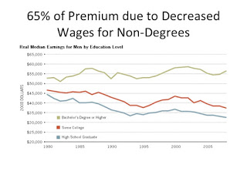
Since 1980, the gap between people with bachelor degrees and people without these degrees has gone up, but 65% of the difference is due to the decreased in median wages for people without college degrees. The real reason for most of the college wage premium can thus be explained by outsourcing, globalization, automation, and de-unionization; in short, there are very few middle-class jobs available to someone without a college degree, but this has little to do with education; rather, in the global race to the bottom, employers have simply sought to increase profits by decreasing labor costs.

Returning to Cassidy’s New Yorker article, what is so striking is that he continues to argue that we really do not know why workers are not making more or why college is not leading to higher wages: “If higher education serves primarily as a sorting mechanism, that might help explain another disturbing development: the tendency of many college graduates to take jobs that don’t require college degrees. Practically everyone seems to know a well-educated young person who is working in a bar or a mundane clerical job, because he or she can’t find anything better. Doubtless, the Great Recession and its aftermath are partly to blame. But something deeper, and more lasting, also seems to be happening.” Although Cassidy makes it seem like it is a giant mystery why there are not enough well-paying jobs for college graduates, we know the answer concerns a set of governmental policies and employer practices that drive down wages and benefits for everyone but the people at the top.

Some economists argue that companies simply have to decrease wages and employment opportunities in order to survive in an increasingly competitive global market. However, we also know that US companies are currently sitting on trillions of dollars of reserves, and they are using hundreds of billions of dollars of profits each year to buy back their own stocks in order drive up their company valuations and increase executive bonuses: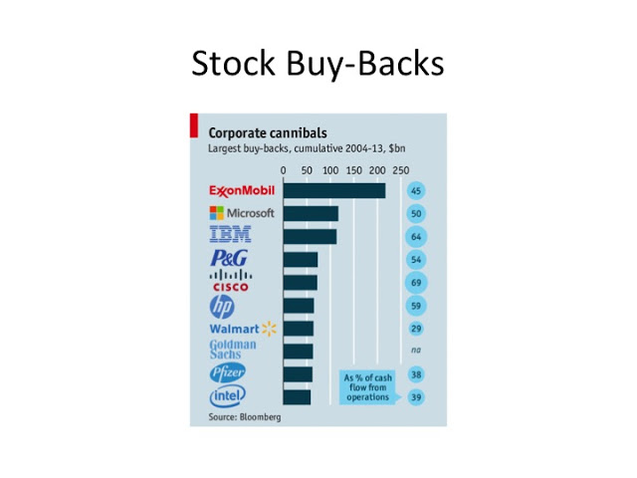
This practice of hording profits and then using it to increase executive compensation has helped to drive the stock market up as most workers see little if any wage gains. Once again, having more people with a college degree will not change this situation.

As many of us now know, 10% of Americans hold over 50% of the wealth, but what most people do not know is that up to 80% of all wealth is either directly or indirectly due to inheritance. As Thomas Piketty has argued, one reason then for the lack of social mobility and the increase in inequality is the way we allow the wealthiest families to retain and enhance their advantages. To highlight this issue, we can look at the top tax rates since 1913 and compare it to income inequality during the same time period:
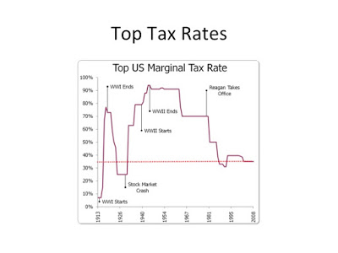
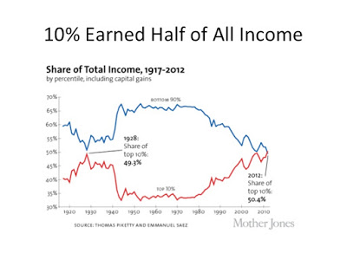
Clearly, we can associate high levels of taxation for top earners with increased inome equality, and so tax policy, and not higher education, plays a huge role in increasing social mobility and decreasing inequality.
Of course, the wealthy have used their financial advantages to not only game higher education but also the political system, which helps to enhance wealth through tax policies and anti-labor practices. Yet, even with all of the ample evidence that most of the wealth and wage inequality is being driven by corporate hording and governmental policies favoring the super-rich, Cassidy continues to argue that we really do not know what is going on: “Why is this happening? The short answer is that nobody knows for sure. One theory is that corporate cost-cutting, having thinned the ranks of workers on the factory floor and in routine office jobs, is now targeting supervisors, managers, and other highly educated people. Another theory is that technological progress, after favoring highly educated workers for a long time, is now turning on them.” Here we see how the focus on technology and education blinds us from seeing how human greed is driving the exploitation of labor, and without any counter-force, like strong unions, governmental regulations, and progressive tax policies, there is nothing to stop the concentration of wealth at the top.

Instead of hoping that higher education should be the solution to all of our economic problems, we should follow Cassidy’s advice and return to the notion that college is a public good and an end in itself: “Being more realistic about the role that college degrees play would help families and politicians make better choices. It could also help us appreciate the actual merits of a traditional broad-based education, often called a liberal-arts education, rather than trying to reduce everything to an economic cost-benefit analysis.” If we focus on making higher education more accessible and affordable as we enhance its quality, we can at least make sure that it does not enhance inequality and decrease social mobility. The first step is to stop believing that college degrees produce good jobs.
Posted by Bob Samuels at 2:59 PM

